SCREEN SHOTS:

After executing the application(by pressing 'RUN'):
Selecting the desired locations(starting and Ending locations):
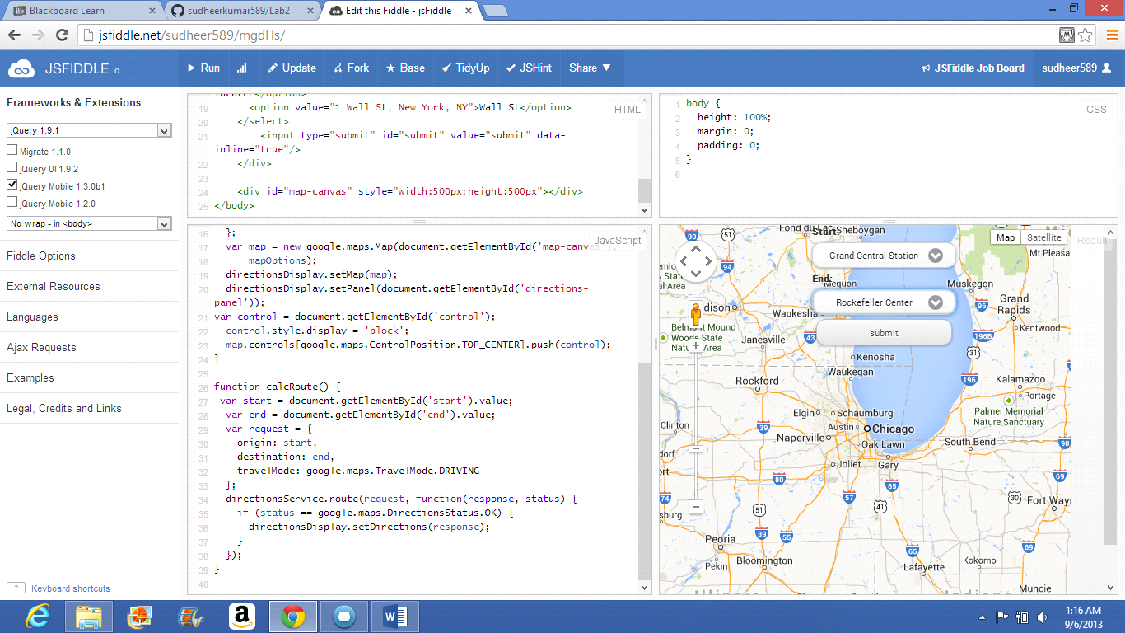

After clicking the Submit button the route displays:
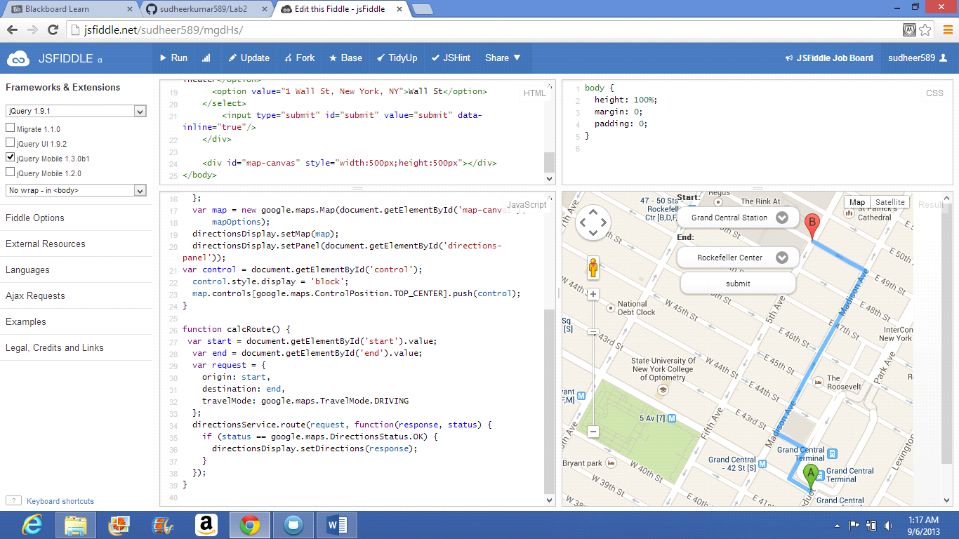

Satellite view of the route:
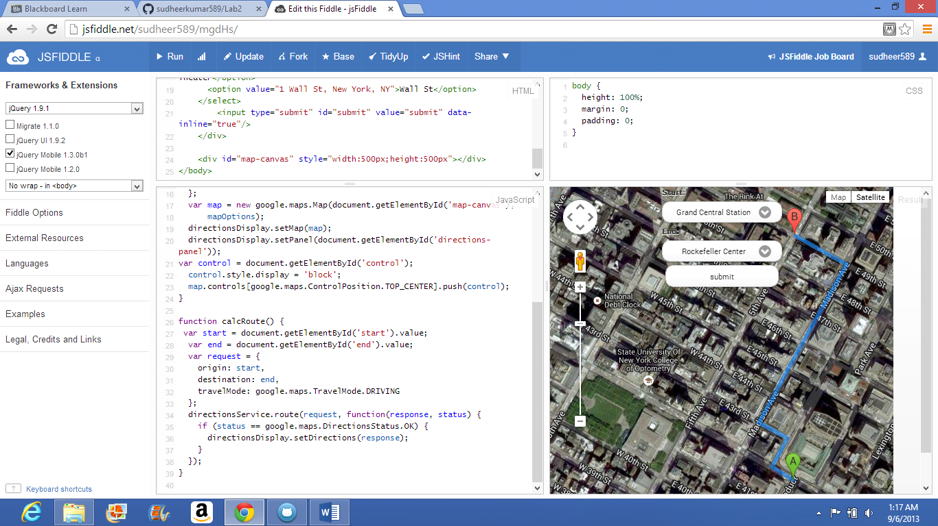

Selecting different locations:
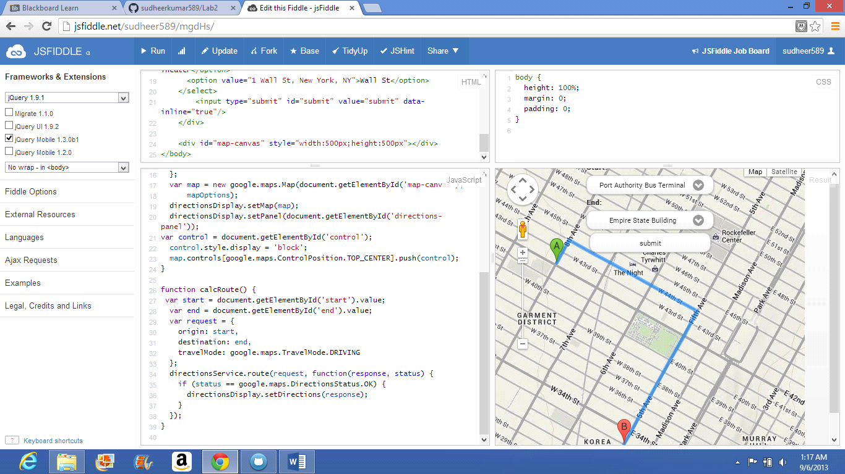

Satellite view of the route:
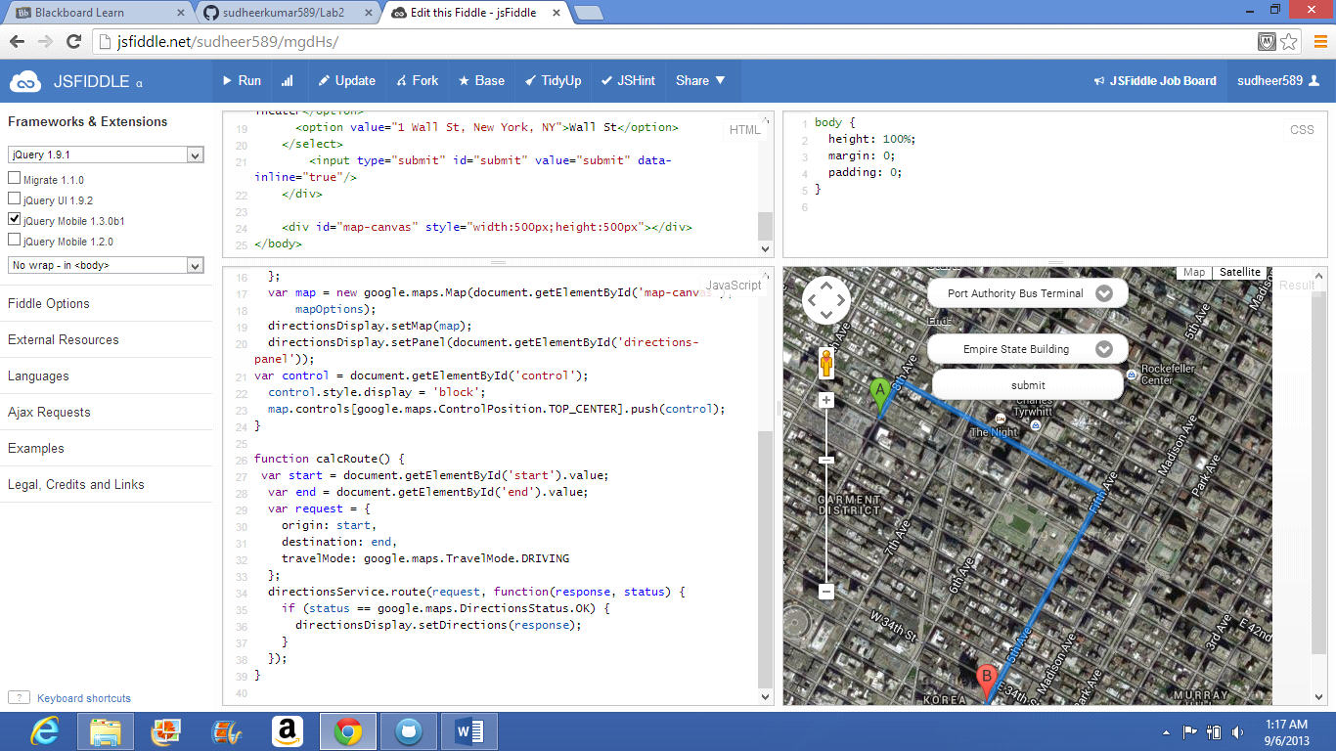

For Mobile debugging:
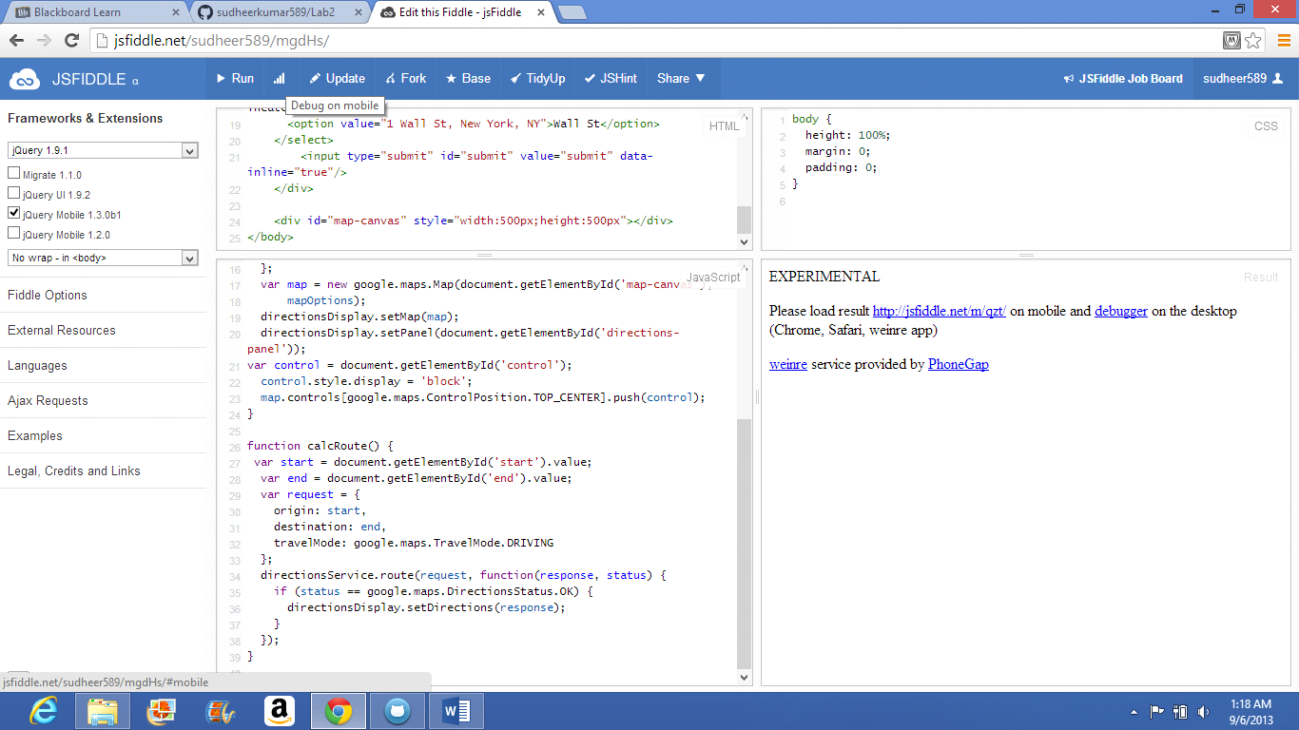

THANK YOU

